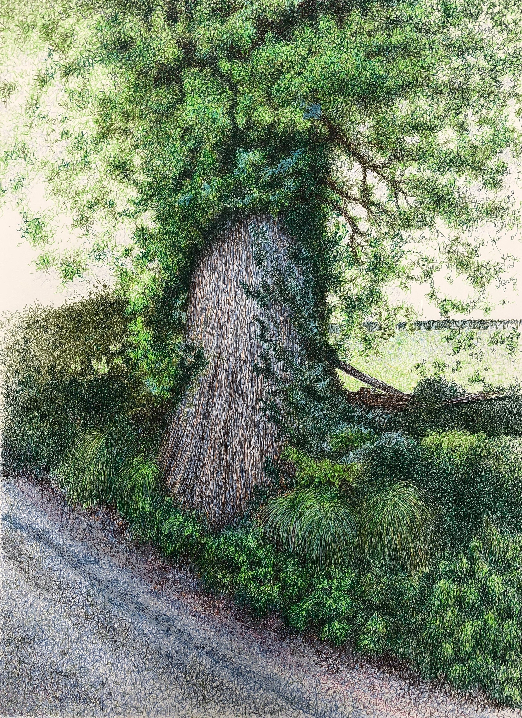

Making a Mark

1st – 31st August 2020  
  
Online Exhibition  
(more details to follow)

Drawings, paintings and mixed media art by the students of professional artist and tutor Mark Lippett.

[www.marklippett.com](http://www.marklippett.com) Image by Mary Wilebur